UAT Plan

for

Tilt Rush

Index

1. Scope 3

1.1. Objectives and business requirements 3

1.2. Scope 3

2. Testing team 4

3. Environmental requirements 5

3.1. Hardware requirements 5

3.2. Software requirements 5

4. Test Scripts 1

# Scope

## Objectives and business requirements

In this section, outline the business requirements. In other words:

* What are our goals? What are we hoping to accomplish with this project/feature?
* How will we measure success?

In this sprint, I will add features for slight flair in gameplay, separate from the main gameplay loop, such as sound effects.

## Scope

In this section, outline the scope. This means:

* What is the pain point we’re trying to fix?
* What are we testing exactly, and what are we *not* testing?

This sprint is mainly for adding documentation for both users and potential future developers, but will also be used to add small final features to slightly improve the experience on the app.

## System Diagrams

In this section, paste any drawings or diagrams that help the UAT team understand the program being tested. With each drawing include a brief explanation of how the drawing represents the application or system being tested.

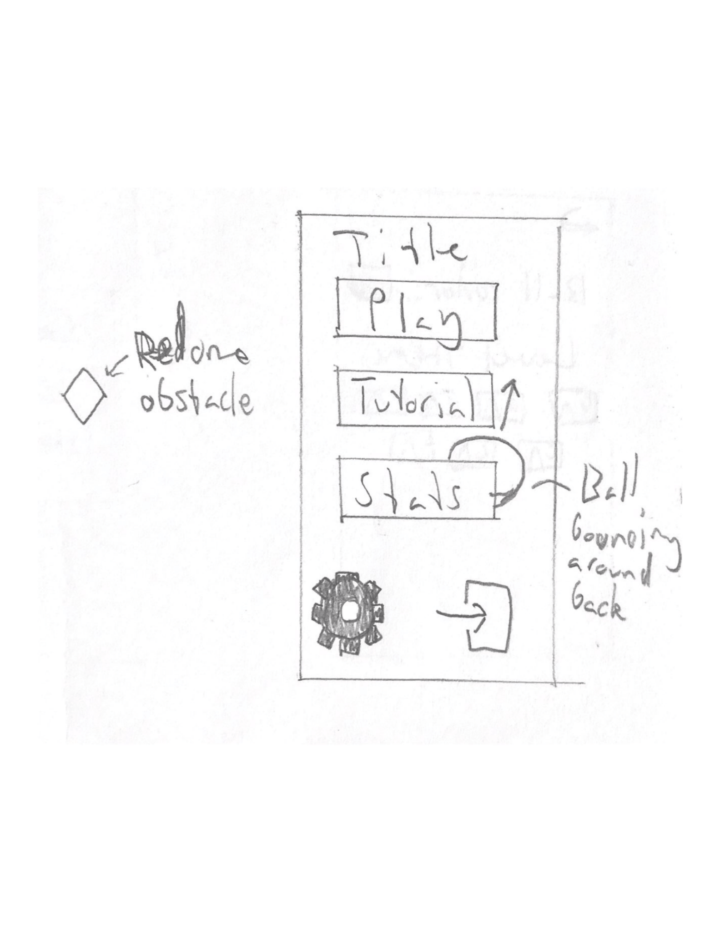

# Testing team

In this section, list out members of your QA team and what their roles will be during UAT.

Example:

| **Name** | **Responsibilities** |
| --- | --- |
| Areesh Khan | To test the final improvements to the application |

# Environmental requirements

## Hardware requirements

What hardware has the solution been designed for and should be tested on.

If that is the case, outline the minimal and recommended requirements so the QA team can verify that the software runs on the testers’ machines.

Phone with online capabilities.

## Software requirements

If any extra software or dependencies must be downloaded and installed, list them here.

* Google Chrome (or similar browser)

## Network requirements

Some software (design, video editing…) can be demanding on hardware specifications.

If that is the case, outline the minimal and recommended requirements so the QA team can verify that the software runs on the testers’ machines.

* Working internet connection

# Test Scripts

This section is more important than it seems—it is crucial that both the QA team and the testers know what features must be tested, especially if you’re testing a lot at once.

| **Test** | **Describe the feature being tested** | **Describe the user input or test data** | **Describe the pass criteria** |  |
| --- | --- | --- | --- | --- |
| 7.1 | Sound effects and music | 1. Press any button 2. Enter the game 3. Hit a wall or screen border 4. Hit a mine 5. Hit a diamond | 1. A sound effect should play when pressing any button 2. 2 different tracks should play on the homescreen and in game 3. A different sound effect should play on each interaction in game | Tester name: Areesh Khan   |  | PASS | | --- | --- | |  | FAIL |   Observations: |
| 7.2 | Vibrations | 1. Enter the game 2. Hit a diamond   Note: will only work if not on safari | 1. A vibration should play when reaching a game over | Tester name: Areesh Khan   |  | PASS | | --- | --- | |  | FAIL |   Observations: |
| 7.3 | Bouncing ball | 1. Stay on homescreen | 1. Ball in background should continue bouncing forever | Tester name: Areesh Khan   |  | PASS | | --- | --- | |  | FAIL |   Observations: |
| 7.4 | Improved level generation | 1. Play the game for as long as deemed necessary | 1. There should not be diamond or wall objects completely blocking the goal 2. This does not include other forms of impossibility | Tester name: Areesh Khan   |  | PASS | | --- | --- | |  | FAIL |   Observations: |

Write step-by-step, detailed but concise instructions on how to test the feature.